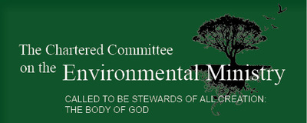
North Carolina Diocesan Committee on Environmental Ministry
Green Grant Program 2022

The North Carolina Diocesan Environmental Ministry Committee currently has green grants available to assist congregations in our Diocese interested in starting an environmental ministry program. Preference will be given to small and low income congregations. Grant proposals can include but are not limited to the following:
●Installing energy efficient lighting
●Beginning a congregation composting program
●Developing green liturgical or religious education programs
●Offering an environmental ministry education series
●Installing water saving technology in campus facilities
●Purchasing reusable dishware for congregation events to reduce waste
●Planning environmentally themed events at the congregation or Diocesan levels
-For example, this could include environmental events for children or youth.
●Creating green worship spaces on campus
●Tree Planting
Grants issued are usually in the $500-1000 range. Grants exceeding $1000 will be considered based on the availability of funds and the monetary needs of the project. To apply, please send a brief (one double-spaced page) description of your project and the amount of the grant you are requesting to Environmental Ministry Committee Chair David McDuffie at dcmcduffie@gmail.com. Please title your emails “Green Grant Proposal.”

